

CS 319 - Object-Oriented Software Engineering

Analysis Report

Syracuse

Supervisor: Uğur Doğrusöz

Group 27

Muhammad Usman

Onur Kulaksızoğlu

Ayşe Kübra Taş

**Table of Contents**

1. Introduction 3

2. Overview 3

2.1. **Gameplay, the Three Layers of Syracuse** 4

2.2. Ages, Victory and Defeat Conditions 7

2.3. Raw Resources and Their Gathering 10

2.4. City Layer: Buildings, Manufactured Goods 14

2.4.1. List of Manufactured Goods 15

2.4.2. List of Buildings 18

2.4.3. List of Wonders and Their Building Conditions 28

2.5. Trade and Diplomacy 29

2.6. Military, Generals, and Wars 35

2.6.1. Unit Recruitment and Units List 36

2.6.2. Mercenary Army Mechanics 40

2.6.3 Ship types 40

2.6.4. Generals 41

2.6.5. Battles,Sieges, and Naval Blockades 43

2.6.6. War 45

2.7. Government, People, Consumption, Storage, and Happiness 47

2.7.1. Population, Housing, and Employment 47

2.7.2. Happiness and Consumption 48

2.7.3. Storage 51

2.7.4. Civics-Government 51

3. Functional Requirements 53

3.1. Start a New Game 53

3.2. Difficulty Options 53

3.3. Settings 53

3.4. View Sicilopedia 53

3.5. Load Game 53

3.6. Save Achievements 54

3.7. View Achievements 54

3.8. General Portraits and Names 54

3.9. Auto Generated Battle Names 54

4. Nonfunctional Requirements 54

4.1. Inform Player 54

4.2. Game Graphics 55

4.3. User Interface 55

4.4. Extendibility 55

5. System Model 56

5.1. Use Case Diagram 56

5.1.1. Play Game 56

5.1.2. View Sicilopedia 58

5.1.3. Load Game 58

5.1.4. Save Game 59

5.1.5. View Trophies 59

# 1. Introduction

Syracuse is a turn based city/state building simulation/strategy game inspired by the game Tropico[1]. In this game the player takes control of the city Syracuse during the antiquity. The main goal of the player is to defend, expand and develop his/her city. This report contains all the information relating to this game. It starts with an overview which details the gameplay interface, the factors affecting the outcomes and different types of gameplay elements. Then it dives into the functional and nonfunctional requirements. And lastly it shows the use cases of this game using a Use Case Diagram and explains them using scenarios.

# 2. Overview

Syracuse is a turn based city-state building simulation game mainly inspired

by the game Tropico[2]. The game gives the control of the Syracuse to the player which was an ancient city-state and regional power in Sicily during Hellenistic Period. Every turn in the game represents one month in real life. Basically, in the game, player will start with a barren colonial city and some raw material sources, as game progresses he will improve his city and trade resources to gain access new resources. As the player gets stronger he will step into new ages, that will give him access to new buildings, soldiers, resources etc. Eventually, in the end player might get stronger enough to conquer whole Sicily from the foreign powers. However, this game is not a sandbox game, player will have to deal with extremely strong foreign empires, his unhappy revolting society, his popular generals who might overthrew him from the throne, economic crisis, sieges, naval blockades etc. In Syracuse player starts as the smallest fish in the sea, and only if he plays wise, he will survive in this age of turmoil.

## 2.1. **Gameplay, the Three Layers of Syracuse**

In Syracuse there are two main screens that game is played, and one grand Mediterranean map that player can use to trace events in the world but cannot interact. First of the main screens is the city-building screen in which player can give orders to construct buildings in coordinates he wants within the city limits, which are restricted by walls. 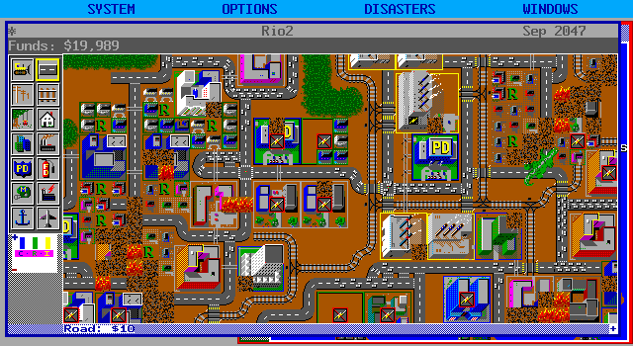

SimCity, one of the earliest city building simulation games[3]

The other main screen of the game is the provinces of Sicily screen. In this screen there will be a map of Sicily that is divided into several provinces (count is not decided yet), three of these provinces represent the big cities of Sicily which are Messina, Lilybaeum, and our city, the mighty Syracuse, and for each of these cities there will be sea provinces that ships can use to blockade these cities. All other provinces will have a raw resource shown in the map that can be produced for the owner of this province. If player owns these provinces he can send people (usually slaves) from his city to those provinces to gather resources. In every new game, the raw resources of those provinces will be redistributed to give different experience to the player. At the end of every month, collected raw resources will be sent to the stockpiles of the city. Other than gathering resources, this map has a different purpose, this map is also the place where wars take place in our game, since map is already divided into provinces this map can support Risk-like wars. Player and his enemies can move their armies between adjacent provinces, conquer others etc. Soldiers that are created by the user will be shown in his city’s province in a Risk-like manner.

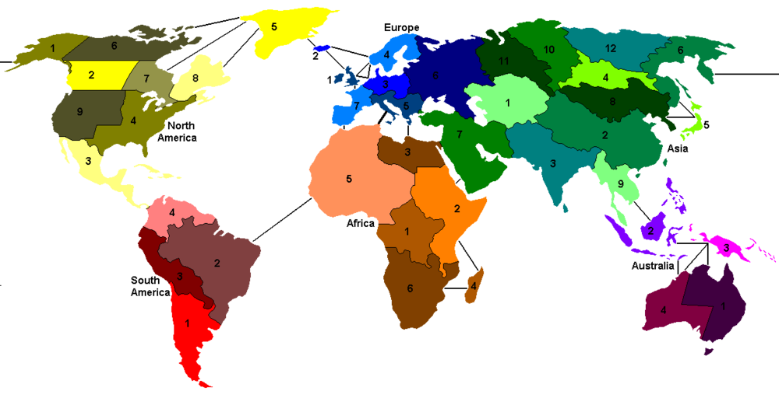

A Risk game map, numbers in each province represent the military strength in that province.[4]

The last layer of Syracuse is not actually a gameplay layer, it is the map of the places that can player can’t interact directly but can be affected indirectly. Means that player can’t conquer these provinces, and can’t be declared war any of the factions in this map with the exception of Roman and Carthaginian Republics. This map is only accessible after reaching to the last age, the Hellenistic Age. Like the previous Sicily map, this map is also divided between provinces that each produces an economic resource, however these resources can be either raw or manufactured ones like pottery or glass for example, unlike the Sicily map which all provinces can only produce the raw ones (provinces’ resources and the number of provinces their shapes etc. will be decided later on). This map is used to track the events happening in other places of the world; to give an example say that player’s city needs wheat import to feed her people, in this map, player can see which countries are producing wheat in their regions, with this information player might want to increase his relationships with this country to later buy wheat cheaper from that particular country. Another example might be this, say player needs iron to produce weapons and solely for this purpose he is in a partnership with Antigonid Dynasty, but if player sees that Antigonid Dynasty lost the province that produces iron to Seleucids, without losing any time, player might want to increase his relationship with this new power. The last and most important purpose of this map, however, is not the gameplay but to increase the satisfaction and role playing elements of the game, when player look at this map he will understand that he is in an alive world, and he is really the smallest fish in the middle of these conflicts. Most of the strategy game players just like to look at maps, and purpose of this layer is to give this satisfaction to the players.

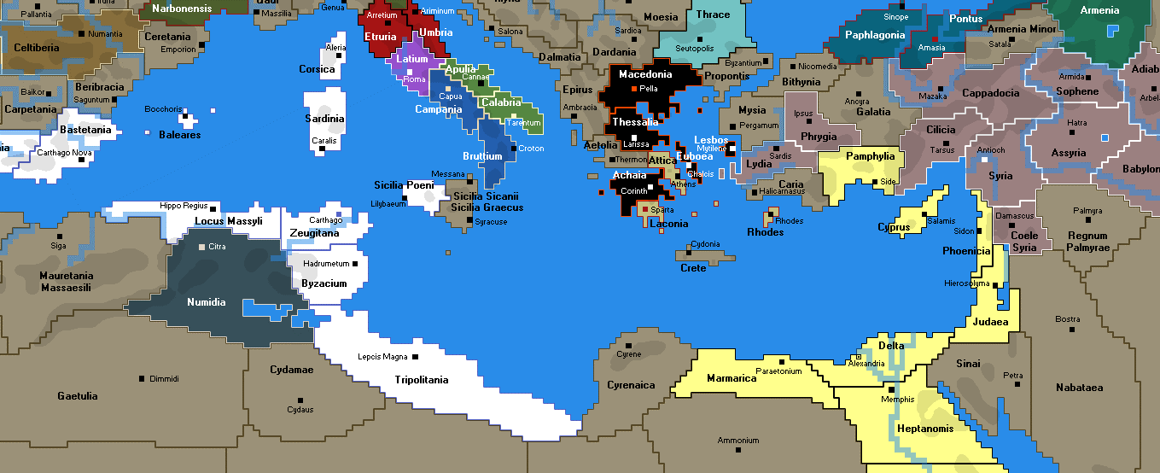

Province map of the Rome: Total War mod, “War of Empires”, our grand map will be similar to something like this, with resource icons added on provinces.[5]

Additional to these more graphical screens, there will be windows that are mostly composed of texts for trade agreements, diplomacy, government changes, military windows, battle reports etc. these screens will be illustrated in their particular subsections.

## 2.2. Ages, Victory and Defeat Conditions

There are three ages in our game, these are: the Greek Colonial Age, Age of the Peloponnesian War, and the Hellenistic Age. Player starts as a colony of mainland Greece. When the game starts, player will have a right to choose two adjacent provinces to his territories in “Sicily map” layer, which will be grant raw resources of the player. Producing military units is forbidden in this level, also since there are no foreign factions yet there is no diplomacy in this age too, but there might be missions from the mainland, the Corinth. Only considerations that player have will be his economy, city buildings, happiness of his people, and the trade. Although there are no foreign factions yet, there will still be trade offers in the trade screen. Additionally many buildings, and some civics will be locked in this age. Player has a time limit in this level so that player can’t stock resources forever and reach the other ages, before this deadline ends player must build a temple in the city, this deadline can be extended by doing missions from the mainland. If player can’t meet the deadline he will lose the game.

The second age in the game is the Peloponnesian War Period, during this period, player will meet with foreign factions for the first time. Also, in this level, player can build military units and buildings for the first time but still cannot invade provinces in the Sicily. Upon reaching this age, player again can choose two adjacent tiles to his territory in Sicily layer increasing his raw resource outputs. The foreign factions in this age will be the Athens and the Sparta, and all the trade offers to the player will be from these two cities. Athens will represent open trade economy, democracy, and naval supremacy while Sparta represents the tyranny, self-sufficiency, and superior land troops. Bonuses and missions given by these two factions will be decided on these attributes, for example to improve his trade export incomes, player may want to be ally with Athens which will be in better terms with the player if Syracuse becomes a republic, or Sparta can support the Syracuse militarily if player agrees on restrictions with trading Athens and his ally cities. Most of these diplomatic movements will have a zero sum result with these two great powers, like trading with one will decrease relations with the other, resulting in an alliance with the one and a declaration of war to another (again if player choose not to declare war until a time period, game will force him to do anyway, to prevent player from stocking resources for later-harder ages). When the war is declared to one faction, player will be given a time period to prepare his city for war, when this time period ends player’s city will be besieged by the enemy power (representing the historical Sicilian Expedition of Athens), after a few turns of siege, if the player has prepared enough he will pass this test and will reach to the 3rd age. In this age, player will learn how sieges, diplomacy, and military recruitment works.

Third age of our game is the Hellenistic Period. In this age player can finally launch military expeditions in Sicily, build his first navy, recruit generals for his armies, unlock most of the soldiers and the buildings, and interact in a more complex trade-diplomacy network. There are six new factions in this age, the Romans, Republic of Carthage, Ptolemaic Dynasty of Egypt, Seleucids of Mesopotamia, the Antigonid Dynasty of Anatolia, and the free cities that are not affiliated with any of these factions. Ptolemaic Dynasty, Antigonids, and the Seleucids randomly declare war to each other, and conquer each other’s provinces again randomly, that results in unstable trade relations for the player that adds flavor to the game, this represents the Diadochi Wars, Syrian Wars and other conflicts between Hellenistic dynasties. Free cities are independent other city states that can be conquered randomly anytime by other five great powers. They don’t appear in diplomatic relations and don’t give missions but can propose trade offers to the player, depending on which resources they have in their territories.   
 Carthage and Rome are the superpowers of their age and they have significant interests in Sicily, they appear on the Sicily map and fight against each other and the player. Since these two powers dislike each other, player again must drive a zero-sum-like diplomatic policy between these two factions. Declaring war to one of these nations without taking support of the other party will most likely to result in a siege in Syracuse and ultimate defeat of the player. Since this part might be extended on “wars” section it is enough for now to know that these two factions are the military rivals and alliances of our city.

In the game’s three ages defeat can be achieved by these: player can’t meet the deadline in the first age, player’s city becomes conquered by one of the Peloponnesian War’s factions during the end of the 2nd age, player’s city is conquered by Carthage or Rome during the 3rd age, player’s city gets conquered by revolting generals or mercenary captains during the 3rd age, if poor people (Proletarii) are unhappy and city is not running the democracy policy, city might revolt and overthrow the player in any age, if rich people(Aristoi) are unhappy and city is not running the oligarchy policy, city might revolt and overthrow the player in any age.

In the game, victory can be achieved by one of those victory conditions: controlling the three cities of Sicily, being in an alliance with Carthage or Rome when the allied faction conquers the other’s capital, building a wonder-like building in the city that requires too many resources. It’s ahistorical but these wonders can be the Greek wonders of the ancient world; like the Great Lighthouse, Colossus of Rhodes, Statue of Zeus, or the Parthenon. Each can be built after completing a special achievement. For example the Colossus of Rhodes can be built only after winning a huge naval war.

## 2.3. Raw Resources and Their Gathering

As previously stated, raw resources can be gathered from the controlled provinces in the Sicily layer by the player, only exception to this rule is the fish resource which can be gathered by the fishing buildings in the city. While their output quantity is not decided yet, the raw resources in the game are the followings:

Fish: Only used for eating by people, must be salted to sell and stock, can be imported as salted.

Sheep: Sheep itself is not a resource, but provinces that have sheeps can produce these resources: cheese, meat, and wool. This resource can be collected by proletarii.

Wheat: Can be processed-milled to create flour, which is used for breads, the most basic food in the game. This resource can be collected by proletarii.

Barley: The most basic grain of the ancient times, can be used to feed animals such as horses or pigs. Can be eaten during shortages of food by the people but gives unhappiness. This resource can be collected by proletarii.

Olive: The trademark of the Greek export in antiquity, this resource can be used to make olive oil which was a great source of income for the Greeks during antiquity. This resource can be collected by proletarii. Trading as a raw resource is not allowed.

Flax: Flax was the main material of clothing during the ancient times along with the wool, can be used to make clothes. This resource can be collected by the slaves.

Marble: After shaped in a stone masonry, marble can be used in construction of some buildings. This resource can be collected by slaves.

Dye: Dye was a very important luxury resource during antiquity, significant examples as “Tyrian purple” helped to shape the ancient history, and in the game it can be processed to make dyed clothes, which are luxury resources that can make your “Aristoi” part of the people happier. This resource is also used by the theatre building.

Grape: Can be processed to make wine in the city. This resource can be collected by proletarii. Trading as a raw resource is not allowed.

Gold and Silver: Can be processed to create accessories, gold cannot appear on the Sicily map since it was very rare in Mediterranean. This resource (silver) can be collected by slaves.

Copper: Can be used to produce armors for the soldiers. This resource can be collected by slaves.

Iron ore: City first must built a forge to make use of iron ore, iron later can be used to produce weapons. Cannot be traded in the ore form. This resource can be collected by slaves.

Timber: Timber represents the high-quality trees of the antiquity, like the cedars of Lebanon, must be turned into lumber before trading or using. Unlike in the most other strategy games lumber is not used for buildings in our game, but it is used for more advanced ships. This resource can be collected by proletarii.

Ivory: Can be used to make accessories, cannot be found on Sicily’s provinces because of obvious geographical reasons.

Salt: Can be used to store meat and fish resources. This resource can be collected by slaves.

Collecting these resources from the provinces will be as following: Each type of resource will have an associated type of people that collects it, slaves or proletarii in our game. Each province will have a limit of 5000 people that can work on its resource, from the count of people that are working in a province, game will calculate the produced raw resource from this province. For example, an iron ore mine with 5000 slaves in it will work at full capacity while a wheat farm that 3000 proletarii working will produce ⅗ of its potential output. This mechanic is decided on to give an alternative way of increasing raw resources to the player, other than invading. Player can send these working people from his city, or can order the return of these people to the city, for instance, after importing slaves from another city, he will come to the provinces screen and click one of them to send these slaves. Additionally some agricultural resources can be collected only in their particular harvest seasons, this feature is added to force the player to plan ahead his grain stocks and consumption, and to give the player a chance of “brokering” like, a player that has enough stockpiles can import wheat during summer and export during winter season to other countries with a higher price. Since every turn in the game is equal to one month, these kind of strategies are possible and advised. However these seasons are not decided yet, after we conduct the research about these agricultural products harvest seasons will be added.

## 2.4. City Layer: Buildings, Manufactured Goods

In the city layer of Syracuse, player will be given a grid that is encircled by city walls and from one direction, by the sea. All buildings that player can build will have predefined length and widths in this grid, for example let city has a radius of 150 units in this grid, and a butchery building will take space of a 2x2 square in this grid (exact values are not decided yet, these values are for the sake of an example). Buildings in Syracuse must be connected to the roads to work on. Every building will have a money cost and some buildings will have additional resource costs, like marble for temples. Some buildings will get additional bonuses when constructed near related buildings to encourage player to form districts, like marketplaces. Only buildings at the start of a game that will be given to the player are a palace, dock, few houses and mansions, and a granary that is partly filled. Buildings will require an amount of aristoi or proletarii people to run like a jewelry shop might require 20 proletarii and 5 aristoi people to run (again these values are just for the sake of illustration). Most buildings will have upgraded versions upon reaching new ages. Buildings can be deleted or upgraded without deleting when an improvement is available. When deciding on the place of the building, player might turn building left or right to fit building into spaces.

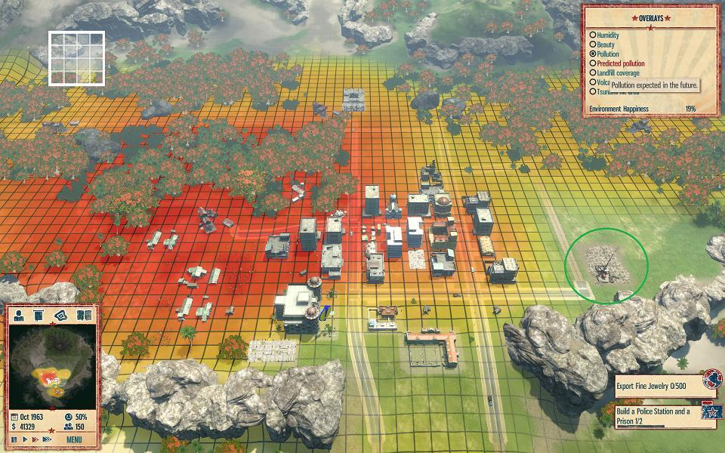

Grid system in Tropico 5.[6]

### 2.4.1. List of Manufactured Goods

Since most buildings have a purpose of producing manufactured goods, it is better to first list the possible manufactured goods in the game:

Flour: Can be produced from mills, by spending wheat, used for making bread. Cannot be traded.

Bread: Can be easily produced in large quantities even from small amounts of wheat and flour, because of this feature bread is very suitable for feeding huge populations, requires bakeries to produce from flour. Cannot be traded.

Meat: Can be produced from porks in the city and from the sheep provinces. Cannot be traded.

Salted Meat: Uses salt and meat as a resource in butcheries and makes the meat storable.

Salted Fish: Uses salt and fish as a resource in fisheries and makes the fish storable.

Cheese: Produced from sheep provinces, doesn’t have a use except consuming, can be stored and traded in the city.

Olive oil: Can be produced from olive raw resource in oil pressers. Olive oil does not consumed as a real food, but gives additional happiness when accessed.

Glass: Glass gives happiness to people and also is a very high profitable for trade purposes because it can be produced from glassmakers without using any raw resources.

Pottery: Pottery gives happiness to people and also is a profitable good for trade purposes because it can be produced from pottery workshops without using any raw resources.

Wool: Produced from provinces that have sheeps. Cannot be traded.

Fabric: Can be produced from wool or flax by fabric workshops.

Dyed Fabric: Can be produced by fabric merchants using a regular fabric and dye resource.

Clothes: Can be produced by consuming fabric by tailors.

Dyed clothes: Can be produced from dyed fabrics by tailors, especially useful for trade purposes and for the happiness of your rich-aristoi people.

Wine: Can be produced in distilleries by using grapes. Makes poor-proletarii people happier, can be used in festivals to boost happiness.

Lumber: Produced from timber by lumber merchants. Used for advanced ships in the game.

Processed Marble: Processed and shaped version of marble for buildings. Needs stonecutter building to produce.

Accessories: Can be produced from ivory, gold, or silver resources by jewelers. Increases the happiness of the aristoi and an important source of trade income for the player.

Armour: Weared by some class of soldiers, armours are produced from armouries by using copper resource. Cannot be traded.

Iron: Produced from iron ores in the forges, used for producing weapons.

Spears- Arrows: Requires small amount of iron to produce, used by most soldiers in the game, requires weapon maker to produce from iron resource. Cannot be traded.

Sword: Used by small but elite portion of the soldiers, requires more iron than the spears and arrows, requires weapon maker. Cannot be traded.

Horses: Horses can be breeded within city walls by spending barley resource in stables, they are used for mounted soldiers. Cannot be traded.

Pigs: Pigs are a cheap way of producing meat thus making your people’s diet more enjoyable for them. Pigs can be produced within city walls in pig farms using barley. Pigs cannot be traded but can be stored.

Slave: Slaves can be considered as a resource in the game, since they can be bought in trade screen, they are bought to work in some raw resource fields.

### 2.4.2. List of Buildings

Some buildings have only the purpose of storing things, so a player that does not produce these resources can still import and distribute these resources, like oil merchant, wine merchant etc. Range requirements are calculated by using how many tiles of road is passed. Agora counts equal to 3 tiles of road. Some buildings require a type and amount of people to run amounts are not decided yet but the types of people that will work on these buildings are given below.

Roads: Connects buildings to each other, all buildings must be connected to the palace by the road network to fulfill their purposes. A road is connected to another road only if it borders in one of 4 directions, so diagonal roads are not considered connected.

House: Used for housing of proletarii people. Available from the start. Can be upgraded to increase happiness or the number of people that live in the building.

Mansion: Used for the housing of aristoi people. Available from the start. Can be upgraded to increase happiness.

Granary: Available from the start, this building is used to store barley and wheat, upgraded versions increase the storage capacity. Aristoi people run this place.

Palace: Given at start, can be upgraded in later ages to reduce the anarchy time during civic changes. Aristoi people run this place.

Docks: Given at start, can be upgraded in later ages to increase the trade ship limit of the city. Any kind of (storable) imported resources can be stored in the stockpiles of the docks. Aristoi and proletarii people run this place.

Fishery: Available from the start must be build near a salt merchant and the sea, produces fish resource, can turn additional fish resources at the end of turn to salted fish and store them. City can have at most one of this building but can be upgraded in later ages to increase the fish output, and salted fish stockpile limits. Aristoi and proletarii people run this place.

Shrines: Smaller temples for the proletarii, provides happiness proportional to the number of “House”s in its range. Available from the start, can be upgraded to increase happiness. If some houses are already in the range of a shrine, additional shrines doesn’t increase the happiness from these houses. Proletarii people run this place.

Temples: Bigger than shrines, these buildings can be used by aristoi to make their prayings, a temple has a greater range than a shrine, happiness is proportional to the mansions in its range. Available from the start, this building requires marble to build and can be upgraded to give additional happiness proportional to the number of shrines and -later- monuments in its range. If some mansions are already in the range of a temple, additional temples doesn’t increase the happiness from these mansions. Aristoi people run this place.

Theatre: Available from the second age, this building has the greatest range of all the buildings and gives happiness proportional to the number of houses and mansions in its range. Required for organizing festivals. Upgraded version of the theatre has greater range. Theatre can give additional happiness to all types of people if player allows the consumption of dye by the theater. This building can be built only once. Aristoi people run this place.

Library: Available in the second age, this building can be built only once, this building is required to archive victories in battles, so player can later look at his remarkable victories. There are no upgrades for this building. Aristoi people run this place.

Academy: Available in the last age, this building must be built near a library. This building converts a number of proletarii people to aristoi people, also increases your general’s strategic qualities by one. Academy converts more people into aristoi if there is an observatory nearby. This building can be built only once. Aristoi people run this place.

Observatory: Available in the last age, this building gives a small bonus to your farming outputs (wheat, barley, grapes etc.) in your provinces, this building must be constructed near a library and an academy. This building can be built only once. Aristoi people run this place.

Mill: Available from the start, this building turns wheat into flour, requires a granary nearby to build. This building can store flour upto a limit in itself. Upgraded versions produces more flour. Aristoi and proletarii people run this place.

Bakery: Available from the start, this building makes breads from flour. Bread cannot be stored nor sold in trade. Must be built nearby a mill. Upgraded versions uses less flour. Production amount can be decided by the player since bread cannot be stored. Aristoi and proletarii people run this place.

Slave Trader: Available from the start, this building is required to import slaves. Upgraded versions and additional slave traders reduces the cost of buying slaves. Aristoi people run this place.

Salt Merchant: Available from the start, this building is required to store salt. Upgraded versions increases the amount of salt stored. Aristoi people run this place.

Fabric Workshop: Available from the start, this building can produce fabric from wool and flax. This building can store dye, wool, flax, fabric, and dyed fabric. Upon reaching the second age upgraded version can produce dyed fabric from regular fabric. 3rd age upgrade reduces the dye costs of dyed fabrics. Aristoi and proletarii people run this place.

Tailor: Available from the start, this building produces clothes and dyed clothes from the fabrics. This building must be built nearby a fabric workshop. Upgraded versions reduces the fabric used. Nearby tailors increases the number of dyed clothes produced. Tailor buildings can store clothes and dyed clothes. Aristoi and proletarii people run this place.

Jeweler: Available in the last age, this building produces accessories from silver, gold, and ivory. Variety of these resources increases the happiness produced from accessories. This building can store silver, gold, ivory, and accessories. The building itself creates happiness proportional to the number of mansions nearby. Aristoi and proletarii people run this place.

Cheese Merchant: Available from the start, this building is required to distribute cheese resource to the people and to store it. Upgrades increases the storage space of the building. Proletarii people run this place.

Pig Farm: Available from the start, this building uses barley to produce pigs, this building must be built near a granary. This building stores pigs, upgraded versions reduces the barley used. This building gets reduced barley costs if there are mansions nearby, to represent the pigs’ waste eating. Aristoi and proletarii people run this place.

Butchery: Available from the start, this building creates meat from pigs, this building can also store the meat coming from the provinces and the meat coming from pig farms as salted. This building must be built nearby a salt merchant. This building is required to be nearby a pig farm if it is gonna produce meat from pigs. Upgraded butcheries increases the meat output from pigs. Aristoi and proletarii people run this place.

Marble-Cutters: This building produces cutted marble from raw marble, this building is available from the start. When upgraded this building increases its cutted-marble output. This building can store both types of marble. Aristoi and proletarii people run this place.

Lumber Merchants: Can create lumbers from timbers, and can store both of these resources. Aristoi and proletarii people run this place.

Olive Presser: Available from the start, this building creates olive oil from olives. Upgraded versions increases the output. This building must be built nearby an oil merchant. Aristoi and proletarii people run this place.

Oil merchant: Available from the start,. This building stores the olive oil. Upgraded versions increase the storage capacity. Aristoi people run this place.

Wine Distillery: Available from the start, this building produces wine from grapes. Upgraded versions increase the output. This building must be built nearby a wine merchant. Aristoi and proletarii people run this place.

Wine Merchant: Available from the start, this building stores wine, and its storage capacity can be increased with the upgrades. Aristoi people run this place.

Metal Merchant: Available from the start, this building is required to store iron, gold, silver, and copper. Storing gold and silver can be also done by jewelers. Aristoi people run this place.

Forge: Available from the start, this building is required to produce iron from iron ores. Upgraded versions produces more iron from same amount of iron ore. Other forges around a forge reduces the iron ore used in production. Reduces happiness proportional to number of nearby mansions. This building can store iron ore. This building must be built near a metal merchant. Aristoi and proletarii people run this place.

Armory: Available from the second age, this building is required to produce armors from copper resource. This building must be built near a metal merchant. This building can store armors. Upgraded versions increases the number of armors produced. Gains bonus to armor production if built near other armories and weapon makers. Aristoi and proletarii people run this place.

Weapon Maker: Available from the 2nd age, this building is required to create weapons from iron. This building must be built near a metal merchant. Upgraded version allows swords to be made, spears and arrows are available from start. Gains bonus to weapon production if built near other armories and weapons makers. Aristoi and proletarii people run this place.

Glass Maker: This building is required to produce and store glass, this building does not use any raw resources. This building can be only built if the player has conquered the Lilybaeum, the Carthaginian city in the Sicily. This is to represent the Phoenician monopoly in glassworks and to reward the player. Aristoi and proletarii people run this place.

Pottery Maker: Available from the 2nd age, this building is required to produce and store potteries without using any raw resources. Aristoi and proletarii people run this place.

Stable: Available from the 3rd age, this building is required to breed and store horses while consuming barley. Aristoi and proletarii people run this place.

Archery Range: Available from the 3rd age, this building is required to create pretty advanced ranged units, such as toxotes and peltasts. There must be a barrack nearby to construct this building. This building can be constructed only once. Proletarii people run this place.

Siege Workshop: Available from the 3rd age, this building is required to construct onagers that gives advantages during attacking cities. There must be a library nearby to construct this building. This building can be constructed only once. Aristoi people run this place.

Barrack: Available from the second age, this building is required to train most units. This building can be constructed only once. Upgraded version allows the training of phalangites. Proletarii people run this place.

General’s Headquarters: Available from the third age, this building increases the number of armies player can simultaneously control in the Sicily layer by two and the number of navies player can control by one. This building must be constructed nearby the palace. This building can be constructed only once. Aristoi people run this place.

Shipyard: Available from the 2nd age, this building is required to build warships. With the third age upgrade ship construction times becomes shorter. There must be a lumber merchant nearby to build this building. Can be build more than once. Must be built near the sea. Aristoi and proletarii people run this place.

Lighthouse: Available from the 2nd age, this building increases the amount of trade offers player gets, there is no upgraded version of this building. Can only be built once, and must be built near the sea. Proletarii people run this place.

Courthouse: Available from the 3rd age, this building must be build near the palace. This building initially has no features, but can gain features from the policies that player using. For example courthouse can give additional happiness proportional to number of “house”s in its range if user is running democracy, or for mansions if player is running oligarchy etc. This building can be built only once. Aristoi people run this place.

Agora: Available from the start, this building represents the trade center of the city and gives significant bonus to all adjacent manufactured goods producer buildings, if there’s a merchant of the produced good, instead only this merchant building gets the bonus. For example jeweler gets the bonus to itself when it’s adjacent to the agora, but olive presser building does not get the bonus for being adjacent to agora, since there’s an oil merchant version of the building. Agora also works as a road for connecting buildings. Agora can be build only once.

Public Bath: Available from the 3rd age, this building gives happiness proportional to the number of houses and mansions in its range, residences that are already in a bath’s range are not counted twice. When adjacent to agora, this building’s range becomes significantly increased. Aristoi and proletarii people run this place.

Monuments: Available from the 3rd age, these buildings can be built only in the next month of an important battle which a popular general defeated a large enemy army. Requires marble to build and gives permanent happiness bonus to government type that is used by the player. For example, if player is running tyranny and wins a large battle, the tyranny civic is permanently becomes marked with a happiness bonus; and whenever the civic is tyranny this bonus is applied again. Monuments must be built near the palace.

Claw of Archimedes: Historically a defending weapon created by Archimedes for the Syracuse, this building is available in the last age. This building requires the library, the academy, and the observatory to be built in city. This building must be built adjacent to walls and can be built only once. This building hurts the navies of enemies if they are blockading the Syracuse’s port.

### 2.4.3. List of Wonders and Their Building Conditions

All wonders can be built only in the last age, and take a lot of time and resources to build.

The Great Lighthouse: Represents the trade power of your city. Requires good relations with at least 4 other factions, and a navy of at least 200 ships.

The Colossus: Represents the naval supremacy of your city. Requires defeating a total of 1000 enemy ships during the game and large amount of copper resource.

The Parthenon: Represents the inner happiness of your city. Requires a minimum amount of happiness of both kinds (not decided on the amount yet) and requires large amount of marble to finish.

The Statue of Zeus: Represents the military might of your city. Requires a general of popularity 10 and an army of at least 30,000 soldiers. Requires large amounts of ivory and gold to be constructed.

## 2.5. Trade and Diplomacy

Trade and diplomacy are closely related in Syracuse since they affect each other with very close ties, trading with a particular nation increases your diplomatic relations, while higher diplomatic relationships gives you advantages on trade agreements. Diplomatic relations are graded on a scale from 0 to 100 with each foreign faction, which 50 means neutral. In Syracuse, each foreign faction has a passive attitude towards you based on your policy choices and your type of goods that are exported, a wheat exporter nation won’t like your competition in the market with them. This passive attitudes can be shifted towards negative or positive directions with recent actions, like trading with them gives, say +10, relations but these short term actions’ impact slowly fades away towards the base passive attitude. So a player must show effort to keep his relations alive.

In Syracuse there are two kinds of diplomacy, first one is one-sided and made against the nations that are not directly involved in Sicily’s affairs. These nations are the Corinthians in the first age, the Athenians and the Spartans in the second age, and the Antigonids, Ptolemies, and the Seleucids in the 3rd age. Since you cannot ask for anything from these nations, diplomatic relations with these countries are restricted to trading with them and accomplishing their missions and requests.

Mission examples from these factions are like the followings:

Corinthians may want you to adopt “trade economy” economic civic, if you haven’t already.

Corinthians may demand resources from you as tribute.

Good relations with Corinth grants income bonus on your raw resource exports and helps you to extend the deadline.

Spartans may want you to adopt the “standing army” military civic, “tyranny” government civic, and the “agrarianism” economic civic if you haven’t already.

Spartans might ask you to build military buildings and recruit soldiers, if you already have above average relations.

Spartans might ask you to stop trading with Athens.

Spartans might ask you to give food resources to them.

Spartans might ask you to declare war on Athens, if you have strong relations.

Spartans can gift soldiers, slaves, and iron resource to you, if you have strong relations.

Athens may want you to adopt the “militia” military civic, “democracy” government civic, and the “trade economy” economic civic if you haven’t already.

Athens might ask you to build religious buildings and build ships, if you already have above average relations.

Athens might ask you to stop trading with Spartans.

Athens might ask you to give non-food resources to them.

Athens might ask you to declare war on Spartans, if you have strong relations.

Athens can gift ships, marble, and dye resource to you, if you have strong relations.

Antigonids might want you to adopt the “trade economy” economic civic if you haven’t already.

Antigonids might ask you to stop trading with Seleucids or Ptolemy if they are at war with these civilizations.

Antigonids might ask you to build religion related buildings.

Seleucids might want you to adopt the “tyranny” governmental civic if you haven’t already.

Seleucids might ask you to stop trading with Antigonids or Ptolemy if they are at war with these civilizations.

Seleucids might ask you to build military related buildings.

Ptolemy might want you to adopt the “militia” military civic if you haven’t already.

Ptolemy might ask you to stop trading with Seleucids or Antigonids if they are at war with these civilizations.

Ptolemy might ask you to build science (academy, library, observatory) related buildings.

The other kind of diplomacy, the two-sided one can be made with Carthage and Rome. Instead of missions, there are agreements in this type of diplomacy. Player can directly declare war to these factions, exchange provinces, make alliances, and can ask for military support from these factions. Same type of things can be wanted by the other side too, of course. During peacetimes it’s possible to be friendly with both of these two factions, but during wartimes both will push player to declare war on the other participant, and trying to stay neutral will just make both factions angrier.

There are no missions in this type of diplomacy but Carthage is more likely to be friendly with the player if he have adopted “mercenaries” military civic and “trade economy” economic civic. Romans are more likely to be friendly with player if he have adopted “standing army” military civic and “guilds” economic civic.

Trade in Syracuse is done by ships, that sails to other factions and cities. These number of ships that can be controlled by the player is limited by the docks level and whether player is running “trade economy” civic. Player can see import and export offers from the trade window in the game. In an export offer for example, the resource and its amount will be shown along with the price of the resource and a duration that shows that when this offer is going to disappear. Every offer’s resource amount, whether it’s an import or export, can be equal to a ship’s capacity or half of it. This way player will have to make choices of selling too many resources at a lower price or selling less at a higher price, and also combining different half-amont offers that goes to same routes. All trade offers’ one side is always “money” there is no bartering in Syracuse, however a ship can be given multiple import and export missions if destination places are the same and there is enough capacity. Thus, while ship is returning it will bring the imported resources and save ships’ travel time. The payment of the exports and the imported resources received when the ship arrives back to the Syracuse, exported resources and the payment of the resource that is going to be imported are taken from the player’s treasury when the ship departs.

How much a faction is going to pay or demand for an amount of resource is always determined by a base price for this resource, some random values, relations with the faction, and the player’s civics. However in the third age, a faction won’t offer to import a resource if the faction's already producing it in its provinces in the grand layer, and if the faction is not producing this resource still price is going to be affected by the other factions’ provinces that this faction is not in war. For example, if Ptolemy wants to import ivory because Ptolemy does not produce ivory in her territories, and Seleucids is a producer of ivory. Now the Ptolemy’s price offer for an amount of ivory will be higher if she is in war with Seleucids than she is not. Player can use this mechanic to be a middleman between two warring states and to make profit, yet this tactic might hurt the player’s relations with the both parties. Also since Antigonids, Seleucids, and Ptolemy’s lands are far away from Carthage and Rome’s, these two group of factions are not considered “trading” when calculating their prices. Since player geographically is in the middle of these two groups, he can be a middleman between these two sides of the world to make profit. For example, since Antigonids and Carthage are not considered as “trading”, if Antigonids are producing iron and Carthage does not have access to iron and at war with Rome, that means player can buy really cheap iron from the Antigonids and sell it to the Carthage, since Carthage has neither iron in her territories nor any iron selling trade partners.

During the first age of the game, only trading partner of the player is the Corinth, the motherland of our colonial city. Some basic resources can be imported from Corinth but luxury resources are hard to see in the trade offers. Corinth however is a good buyer of your exports and don’t care about their varieties or types, yet they won’t pay too much to your products. Every shipment costs one month-turn to send and return in this age.

During the second age of the game there are Sparta and Athens as trade partners of the player, Athens will export luxury part of the trade offers while Spartans usually sell food resources, also Athens tries to buy food, while Sparta tries to buy luxury resources. Every shipment costs one month-turn to send and return in this age.

During the third age mechanics work like explained above, all factions export the resources they have in their “provinces” and import ones that they don’t have, but price is affected by their war-peace situations with other factions. Additional to these things, there are “independent cities” faction that none of the above 5 factions of the third age control. These cities has no diplomatic relation with the player (always considered 50 relation points, does not change) and considered as in peace with the all nations when calculating import-export offers’ prices. These cities themselves create trade offers too, but unlike the other faction’s cases they can import a resource that another independent city state controls since these cities are not unified, yet the buying price of this resource will be decreased since the city state wants this resource counts as in peace with the other city state that produces this product in its province. Since these city states can get conquered by other 5 big nations, they are not very reliable in terms of trade. Shipments that sent to or returning from Antigonids, Ptolemy, and the Seleucids takes two months-turns to arrive. Shipments that sent to or returning from Romans, Independent States, and the Carthage takes one month-turn to arrive. So with the mechanics explained above, for example the player can take the payment of the resource sold to Antigonids only after 4 months passed, two months for departure and two months for arrival.

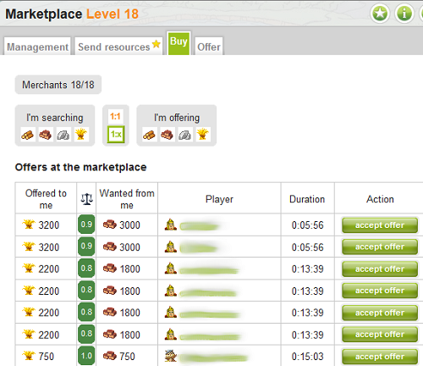

The trade mechanics of the browser game Travian is similar to ours, except few differences that are described above[7].

## 2.6. Military, Generals, and Wars

Military in Syracuse especially important for the player during the 3rd age. The player can recruit basic units in 2nd age, and recruit more advanced ones in the 3rd age. Additionally, army general mechanics start in the third age too, that grants player the ability to form “Expedition Armies” that can be sent to other provinces in the Sicily map, soldiers without a general can’t leave the city and can only defend.

### 2.6.1. Unit Recruitment and Units List

To start talking about the military it’s better to describe how unit recruitment works and what are the units. Land units can be produced in three ways in Syracuse and all the ways require money to produce-acquire units. One by having militia units, that are usually weak, cheap, and good at defending the city and since they are normally working people during peacetime militias don’t have much effect on your manpower except the wartimes. The other way is by hiring mercenary armies in the 3rd age, mercenaries require neither resources nor manpower to hire, but they require significant amount of money to recruit and to continue their contracts, they are hired with their already attached general who cannot be replaced. Mercenaries also can revolt if player tries to disband them and if the mercenary army is significantly powerful compared to rest of the player’s military strength. Mercenary armies cannot be garrisoned in the city of Syracuse, thus cannot defend in an event of siege. Additional mercenary army compositions can be unlocked by having good relations with Antigonids, Ptolemy, and the Seleucids. The last way of recruiting units is to creating standing armies. This type of recruitment requires pretty large amount of resources, manpower, and training time. These soldiers are as qualified as mercenaries yet require less monthly payments and are more loyal to the player. Militias and standing army units are recruited in the groups of 500 soldiers, except the mounted units which are the groups of 100’s and onagers which require 20 people to operate. Mercenaries come with already formed armies.

The units in the game and their advantages are as the following (units’ exact base power, recruitment costs-resources, and percentage of bonuses to other units are not decided yet):

Hoplites: The most basic unit in the game, fights with a spear in melee, requires spear-arrow resource to recruit, have short recruitment times, trained as a militia unit. Proletariat people can form the hoplite units. This unit does not have any bonuses. Is a melee infantry unit. Available if player has barracks.

Slingers: Throws stones, the most basic ranged unit of the game. Does not require any additional resources to produce, can be formed from proletariat. Fights better against unarmored soldiers and while defending cities, otherwise a very weak unit. Trained as a militia unit. Is a ranged unit. Available if player has barracks.

Peltasts: Javelin throwers of the Ancient Greek. Requires spear-arrow resource to build, can be formed from proletariat. Fights better against armored melee infantry soldiers of the enemy, fights better when defending cities. Requires archery range to recruit. Is a ranged unit. Trained as a standing army unit.

Toxotes: Archery unit of the Ancient Greek. Requires spear-arrow resource to build, can be formed from proletariat. Fights better against melee infantry soldiers of the enemy, and gains bonus proportional to the size of the army they are in. Fights better when defending cities. Requires archery range to recruit. Is a ranged unit. Trained as a standing army unit. Can be also found in Roman armies.

Phalangites: Backbone of the Greek armies, these strong units carry long spears and are armored infantries. Requires armor and spear-arrow resource to recruit, can be formed from the proletariat. Fights better against mounted units, and the hoplites. Trained as a standing army unit and is a melee infantry unit. Requires upgraded version of barracks.

Hetairoi: Shock cavalries used by the Alexander the Great, these units require sword, horse, and armour to recruit. This unit has bonuses against unarmored infantry and ranged units, this unit also gains bonus proportional to the number of hetairoi units in the army and the tactical abilities of the commander. This unit can be formed from aristoi people, is a mounted unit, and trained as a standing army unit.

Onager: Siege engines of the ancient times, this unit can be recruited without using resources except the money, unit can be formed from aristoi people. Onagers helps to neutralize the bonuses of the city defenders when attacking cities. This unit is trained as a standing army unit. This unit becomes destroyed if the army it’s in loses the battle. Can be found in Roman armies.

Manipulus: The legionaries of the Roman army, can be recruited by the player only if the player has conquered the Messina in Sicily. Requires sword and armor to recruit, can be recruited from proletariat. Can be found in Roman armies in the Sicily. Fights better against other infantry units and when attacking cities. Considered as a melee infantry and a standing army unit.

Equites: The cavalries of the Roman army, cannot be recruited by the player. Has no bonuses. Considered as a mounted unit.

Numidian Cavalry: The cavalries of the Carthage army, cannot be recruited by the player. Has bonuses against mounted units and gains extra bonuses if the enemy’s cavalry forces are smaller than that of Carthage’s. Considered as a mounted unit.

War Elephants: The most interested instrument of the Carthage’s war machine, these units are unmatched in the open field battles and has bonuses against all the units that have no bonus against mounted units. Considered as a mounted unit. This unit can also be found in mercenary armies.

Balearic Slingers: Basic ranged unit of the Carthage’s armies. Has bonuses against other ranged units. Considered as a ranged unit.

Libyan Infantries: Basic infantry unit of the Carthage’s armies, has no bonuses. Considered as a melee infantry unit.

Tarantine cavalry: Can be found in hirable mercenary armies, has bonuses against mounted units. Considered as a mounted unit.

Mercenary Hoplite: Stronger than regular hoplites, these units exist in every mercenary army that is hirable, has a slight bonus against other melee infantry units. Considered as a melee infantry unit.

War Chariots: Can be found in hirable mercenary armies, this unit gains bonus as the enemy army’s size becomes smaller than yours, resulting in losing less soldiers in the battles that you are already the stronger participant. Considered as a mounted unit.

### 2.6.2. Mercenary Army Mechanics

Mercenary armies are not loyal to the player as the other troops, since their wage is too high player will want to disband them after a battle finishes, however mercenary generals won’t accept that easily if they form a strong portion of your military power and this might result in civil wars. During a revolt mercenary army claims the province they are in for themselves and starts conquering other provinces until they are defeated.

Available mercenary armies with different sizes and generals are offered as it happens in trade section every turn. Normally these mercenary armies only consists of mercenary hoplites, but if player has good relations with Antigonids, Seleucids, or Ptolemy; these armies can include Tarentines, War Elephants, and War Chariots, respectively. After a mercenary army is hired in the mercenary window, the army will appear next turn on a province next to the Syracuse. Mercenary armies might refuse to attack larger forces, again depending on the strength of the rest of the player’s army.

### 2.6.3 Ship types

All war ships in Syracuse must be built directly by the player since there are no mercenary navies in the game. Ships are used to blockade ports, prevent land interventions of other powers, and attack other navies. Carthage, Rome, and Syracuse have both the same type of ships available.

Ship types in Syracuse are:

Trireme: Only available ship from the 2nd age, this ship does have a bonus against ramming ships. This ship does require small amount of lumber resource, but requires 90 slaves and 10 aristoi to crew the ship.

Ramming ship: Available from the 3rd age this ship has bonus against polyremes. This ship requires small amount of lumber and 25 slaves and 5 aristoi to crew the ship.

Corvus ship: Available from the 3rd age this ship has no bonus against any ship, but can capture enemy ships if the battle has won. This ship does require small amount of lumber resource and requires 80 slaves, 50 proletariat, and 10 aristoi to crew the ship.

Polyreme: Available from the 3rd age, this ship has bonus against corvus ships and triremes. This ship requires large amount of lumber and 180 slaves and 20 aristoi to crew the ship.

### 2.6.4. Generals

When a group of soldiers or ships are selected from the city to move to another territory in Syracuse, a general must be attached to them from the available list of generals. Since mercenaries are already hired with their generals included, this process is not required for them. Player can have 2 armies and one navy by start, these available numbers can be increased by building general’s headquarter building. There are 4 attributes in Syracuse that generals are ranked between 0 and 10. The first attribute is strategic abilities, this attribute gives combat bonus when controlling large powers and increases the retreat possibility. The second attribute is tactical abilities, this ability gives combat bonus when controlling smaller forces and reduces the enemy’s retreat chances. The third attribute is a general’s naval understanding, this bonus is straightforward and gives combat bonus when this general is controlling navies. The last attribute is the popularity of a general, upon winning large battles the city receives a happiness bonus in Syracuse, and popular generals increases this bonus in the city. However if the city is unhappy in general, if a popular general thinks he has an army of enough strength, he can try to overthrow the player. This betrayal mechanic is similar to the mercenary rebellion mechanic, which an army claims a province and starts conquering adjacent ones and maybe eventually conquering the Syracuse itself. When popular generals are called to the city to detach them from their army, this mechanic might be triggered considering the power of the general’s army and the happiness situation in the city. Another property of generals is their age, generals can die because of their age, if a general dies while running an army player will be asked to attach a new general from the general pool. Another feature of the age attribute is that young and successful generals can accumulate popularity attribute easier than the older ones.

As mentioned above, there is a pool of randomly generated generals when user wants to choose the general with random attributes. This pool will have a size of 3 or 5 probably but this is not decided yet. When generals are controlling armies can improve their abilities by winning wars. Additionally every year (12 turns) this pool is refreshed except the generals who once selected by the player and then returned to the city. When tyranny governmental civic is chosen player can choose the “tyrant” as a general too, tyrant receives extra happiness from winning battles and cannot betray to the city, however if tyrant dies in battle player will face one turn of anarchy (player cannot order any constructions).

### 2.6.5. Battles,Sieges, and Naval Blockades

A battle occurs when an army attacks another, defeated side’s army transfers back to the this country’s city if can achieve retreat. Victor army controls the attacked province. Battles’ results are calculated using the units and their varieties in both sides’ armies, generals’ abilities, some additional modifiers if there are any, and some random values to prevent battles from being completely deterministic. In Sicily map every army can make only one movement or attack to an adjacent territory. Two armies cannot be stacked in same province. If player or any other nation in Sicily map chooses to do, one can attack an enemy army using multiple armies in same battle, if all of his armies are not moved this turn and are adjacent to the target province. In this situation the armies will be considered as one, and the army will benefit from the general with the higher strategic abilities’ strategic leadership modifiers-bonuses; yet all generals’ tactical abilities will be applied to their own smaller armies to calculate their total power. So it’s very useful for the player to divide his armies into chain of commands, that multiple armies ruled by a higher level general that has greater strategic abilities, and armies controlled by his subordinates that have smaller forces with their tactical abilities. The happiness gained from these type of battles are calculated using the popularity of the general with the highest strategic abilities. Conquer of a province or defeat of an enemy army will grant slaves to the player in the city.

Sieges occur when an army tries to move to an enemy’s “city province”, during sieges the sieger pays additional money to his soldiers. During sieges cities lost connections to their “provinces”, so raw resources except the fish cannot be gathered during the sieges. This is the cost for the besieged city, if there aren’t enough grain stocks city can starve for example. Sieges last for a few months that is not certain to any sides of the battle, after this random number of months are passed the battle calculation will be made. Sieges always last longer than three months and can continue for three years at most, if the attacker has bringed onagers with him or has ships that are also blockading the port of the city, sieges length might be shortened. When the battle is calculated, if the attacker can’t win the battle he can still continue to besiege the enemy to bring additional forces and to continue to the siege. If the besieger has lost the battle yet didn’t lift the siege, a new battle will be calculated within four months. Also at any point during the siege, the defendants can leave the city to attack the siegers with a portion of their army and with an attached general, this battle will be calculated as a field battle, so units such as archers can’t get city defence bonuses during this counter-attack. If this counter-attack becomes unsuccessful the sent soldiers will all be dead. During sieges city can continue to recruit soldiers, build ships, and construct buildings etc. only restriction will be on the gathering of the raw resources. If the defender is the player, player will be able to appoint a general to the defence of the city from the pool when the siege starts, this general will be used during the calculation of the battles. During the siege at the end of 2nd age, since there are no generals yet rules about generals won’t be applied to this siege.

Naval blockades happen when an enemy navy stays in the city’s adjacent sea province. During blockades the blockaded city cannot trade resources. Additional to this any trade ship that are already in foreign seas will wait in the destination factions until the blockade stops. Since trade is crucial for some resources to the player, a city that is blockaded can stop the player’s progression in the game. Blockading the enemies’ port has enormous benefit for the player too, blockading the Lilybaeum’s port stops Carthage from sending armies to the Sicily and blockading Messina does the same for the Romans. If these ports are blockaded the first goal of the Rome and Carthage is going to be the lift these blockades. Also ai will know the power of this mechanic too, the faction with the stronger navy will always try to blockade the other side of the Sicily to safely expand on land.

### 2.6.6. War

There are two types of wars in Syracuse. One is pseudo-wars of the 3 Hellenic factions, and the other is the real wars between Rome, Carthage, and the player. 3 Hellenic states declare war one to another if the two share a border in random time periods. Usually these wars last for 5-15 years and there are later 5-15 years of peace between these two factions. Every month there is a little probability that one of the sides of the battle can conquer a territory from the other, when this probability occurs, one of the provinces that borders the conqueror nation will be passed to the conqueror, this province is more likely to be a province that the conqueror nation has more borders with. During peacetimes these 3 hellenic state can still conquer the independent city states. This pseudo-wars enrichens our game and creates economic waves to make game more interesting.

The “real wars” of Syracuse can be declared randomly between Carthage and Rome if the player is passive, or can be initiated by the player if the player has good relationships with one of the sides and persuades this faction to declare war to another in diplomatic screen. If there’s a peace between these three actors, Carthage and Rome can conquer free cities that borders them during peacetime. If Carthage and Rome shares a border in someplace else and not in Sicily, and if player does not interfere in their affairs, they might choose to fought their war in the “grand map” layer in a pseudo-war manner, meaning that randomly provinces will change their owner like the wars between three Hellenic factions. However, if these two factions share a border in Sicily or the player decides to engage in the war, these two factions will always prioritize the Sicily in the war and land their troops in the island. During the wars that player supports one of the factions, the supported faction will try to protect Syracuse from sieges and blockades of the enemy. During peacetimes these two factions will draw parts of their forces from the Sicily. In Sicily map, player can see the number of soldiers and ships in each province and their types. If one of these two factions completely repelled from the Sicily, they will try to recapture their respective cities by landing troops and sieging either Messina or Lilybaeum. During wars in Sicily, depending on some random values and the how battle is going for this faction, a faction might embark troops to Sicily between random time periods, mostly between 20000-50000 soldiers, Rome can send larger land armies while Carthage can send larger navies to Sicily. If the battle is declared recently army’s strength will be higher. Controlling Messina and Lilybaeum works like controlling a province in the grand layer, meaning that the faction that’s controlling the Messina accepted as bordering the south tip of Italy, while the controller of Lilybaeum considered bordering Tunisia. If there is no enemy left in the Sicily for a particular faction, war might continue on the “grand map layer” for this faction meaning that this faction can conquer these “bordering provinces” in a pseudo-war manner. As stated in the victory conditions, if player is an ally of one of these two factions and the ally of the player conquers the capital of the other, game is considered won. If player conquers another city in Sicily layer, he can’t control this city like the Syracuse, but the conquered city pays huge amount of tributes each month to the player.

## 2.7. Government, People, Consumption, Storage, and Happiness

### 2.7.1. Population, Housing, and Employment

In Syracuse there are three types of people that player will control, these types are based on the people's economic classes. The first class of people in Syracuse is the Aristoi, aristoi represents the free, rich, and educated portion of the population. Aristoi usually live in the city, works as tradesman, fight as highly equipped cavalries in battles, and needs luxury resources to be happy. The second class in the Syracuse is the Proletariat, actually being a Roman term, proletariat is chosen because of the word’s popularity, the proletariat represents the free yet poor portion of the people that does not control any means of production, proletarii people usually works as artisans or farmers in the game and forms the most of the military forces, proletariat becomes happy when they are feed and drunk well. The third class of the people in Syracuse is the Slaves, slaves can be sold or bought as resources in the game and usually works in places like mines, quarries, and serve as oarsman in the war ships, slaves’ happiness is not a consideration in the game. Slaves only need basic food items.

Of these three types of people, the proletariat and aristoi people breed and increase in numbers every month; their population growth rate is affected by their happiness, whether they live in the countryside or in the city. The slaves, however are not allowed to reproduce in Ancient Greece and every year, some of them dies when working in countryside provinces. To stop his production from falling, player must constantly import slaves or create slaves by fighting in wars.

The proletariat and the aristoi can live in the city’s mansions and homes, player must build mansions and houses to meet the demand of housing, if there is no available houses in the city, city population cannot exceed the limit and becomes capped. If a proletariat’s province is already at its population cap, newly born people are transferred to the city if there’s available housing of course. Housing is considered only for the people live in cities, the people in the army and the navy are also considered as living in the city.

Other than being housed or not every person has a job or not too. Player can see the number of these unemployed men and can open workspaces for them in the city or can conscript them for the army or the navy.

### 2.7.2. Happiness and Consumption

In Syracuse there are two kind of happiness in the game, one is for the aristoi and the other one is for the proletarii. These two types of people have sometimes common pleasures but they usually differ in the government types and the things they consume.

In Syracuse there are three kind of resources, with respect to their consumption. First kind is not our interest in this section, these resources are the raw resources that cannot be consumed but must be turn into something else, or the resources like lumber or iron that are not consumed but used to create military equipments, buildings etc. Second kind of resources are the foods, these resources are always consumed in an amount parallel to the people living in the city and the countryside. Example to these resources are the fish, meat, cheese, bread etc.The third type of resource is the ones that are required by the people but are not needed parallel to the number of people. These type of resources include pottery, glass, accessories. In this third kind of resources market can be fed up to the resource and the consumption amount of these resources are calculated by adding the newly born people to the small portion of previous population. This kind of consumption represents for example the everyone’s needs for having clothes, but not buying every month for example. Briefly in Syracuse resources are consumed in the amounts of these idea of calculations. When player can meet the consumption needs of the people in these resources this grants happiness to the people.

Also some resources are only consumed by some type of people in the game, like since a proletarii can’t buy dyed clothes, having dyed clothes in storages does not matter to proletarii.

When the consumption demands met, every resource provides different amount of and different kind of happiness. These amounts are not exactly decided yet, but we can at least say whether it’s large or small.

Salted meat and regular meat: Food type of consumption, demanded by aristoi and proletariat. Gives medium amount of happiness to aristoi and large amount to proletariat.

Salted fish and regular fish: Food type of consumption, demanded by aristoi and proletariat. Gives medium amount of happiness to proletariat and medium amount of happiness to aristoi.

Wine: Food type of consumption, demanded by aristoi and proletariat. Gives medium amount of happiness to aristoi and large amount to proletariat.

Olive oil: Food type of consumption, demanded by aristoi and proletariat. Gives large amount of happiness to both parties.

Bread: Food type of consumption demanded by aristoi and proletariat. Gives small amount of happiness to aristoi and medium amount to proletariat.

Cheese: Food type of consumption demanded by aristoi and proletariat. Gives small amount of happiness to aristoi and medium amount to proletariat.

Clothes: Goods type of consumption demanded by proletariat. Gives medium amount of happiness.

Dyed Clothes: Goods type of consumption demanded by aristoi. Gives large amount of happiness.

Pottery:Goods type of consumption demanded by proletariat. Gives medium amount of happiness.

Glass:Goods type of consumption demanded by aristoi. Gives large amount of happiness.

Accessories: Goods type of consumption demanded by aristoi. Gives large amount of happiness.

In this table, “goods” type of consumption is done for individual resources, meaning that available accessories does not reduce the consumption of glass. Yet the food production and its grant of happiness works little different. First, every food that’s currently available in the city’s aristoi happiness points are summed, that point is the happiness that is gained for the aristoi from foods. Then the total food need of aristoi is divided to the number of foods available in the city, then this number is subbed from each food’s storages. Than the same operation is done for the proletariat. Any resources that are not enough to meet the demand subtractions, give only a ratio of their happiness values. Also if there’s no dyed clothes same operation can be done for the clothes, first aristoi buys their clothes than the proletarii or if there’s no glass in the city storages aristoi first consumes the pottery, however from these two consumptions aristoi does not gain any happiness. Slaves always eat the cheapest food possible. During the sieges, player does not have to feed the countryside people.

Happiness gained from consumption is calculated like the above description, when this happiness is summed with sources like buildings, policies etc. result of two kind of happiness are found.

### 2.7.3. Storage

In Syracuse, some buildings have storage capacities, yet player does not have to deal with them individually. Player can manage storages as all storages in city are added together for all types, like if there are 3 salt merchants in the city, instead of clicking them one by one he can view their total storage/storage capacity ratio in a panel. From this panel player can forbid the selling of some resources to the people, say player’s aristoi people are already happy enough, so he doesn’t want to waste his accessories on these already happy people and wants to export them for income. He can give an order to jewelers to hold their products, and can later sell them to the other countries. Also, from this panel, he can restrict the meat production from pigs because there is a salt shortage so additional meat cannot be stored etc.

### 2.7.4. Civics-Government

In Syracuse player can choose between 9 civics from 3 categories to gain bonuses to his rule. These categories are like the following: governmental, economic, military. Each time the player changes civics he faces 3 months of anarchy so that player can’t order construction of buildings during this period, anarchy time can reduced up to 1 by palace upgrades. The 9 civics in the game and their descriptions (the exact bonus values will be certainly decided later on implementation) are like the following:

Governmental:

Tyranny: Government of one man, tyranny allows to make your tyrant a general. Tyranny gives reduction in building costs except the wonders. Tyranny makes your courthouse give happiness proportional to military buildings in its range.

Oligarchy: Government of the aristoi, oligarchy gives bonus income on your trade exports. Oligarchy also makes your courthouse give happiness proportional to the number of mansions in its range.

Democracy: Government of the free men, democracy gives reduction in your import costs. Democracy also makes your courthouse give happiness proportional to the number of houses in its range.

Economic:

Trade Economy: Player’s trade ship’s cargo space gets increased by ½ resulting in more trade income.

Agrarianism: Player’s farm incomes are increased.

Guilds: Player’s manufactured goods producer buildings in the city gets production bonuses.

Military:

Militia: Armies gain combat bonus when defending cities or provinces.

Mercenaries: Wage of mercenary armies gets lowered, and betrayal chances are decreased

Standing Army: Phalangite and Hetairoi units gain massive combat bonuses.

Player can change these civics from any age.

# 3. Functional Requirements

## 3.1. Start a New Game

Player can start a game from very beginning by clicking that button. After that, if player click on start button, game would start with default settings and options.

## 3.2. Difficulty Options

This function provides player to choose difficulty options in terms of economy and military. Player can choose easy, normal or difficult options for both scope.

## 3.3. Settings

Player can compose a user name and decide a profile picture for himself on settings part, before starting a game, to increase the roleplaying elements.

## 3.4. View Sicilopedia

This part includes descriptions of buildings, resources, units etc. Also, there will be explanation about concepts of the game like diplomacy and trade. Briefly, player gets help from this part to play the game.

## 3.5. Load Game

Player will be able to save and load games. Previous game will load with its chosen settings and options.

## 3.6. Save Achievements

During the game, player can save his battle reports, if he has built a library.

## 3.7. View Achievements

Player can view his achievements which are saved before.

## 3.8. General Portraits and Names

Game will choose random names and pictures for the general portraits, this function can increase the role-playing elements. These portraits are most likely to be antique sculptures.

## 3.9. Auto Generated Battle Names

While creating the battle reports game will generate names for the battles like Battle of Bloody Fields, Battle of Dark Moon etc. from predefined adjective and nouns to increase the role-playing effect on the player.

# 4. Nonfunctional Requirements

## 4.1. Inform Player

Syracuse game is played in ancient times and include many details inside. Therefore, there will be a sicilopedia menu including description of items in the game and explanation of how to play game. Players do not need any pre-knowledge about the ancient times or such city-building games.

## 4.2. Game Graphics

With the game graphics, we plan to affect players to keep them playing so graphics will be impressive as much as we can. They will not be too complex but instead intelligible.

## 4.3. User Interface

Game is played in three main layers and windows. User interface will be simple so, player needs to spend his time thinking about strategies rather than clicking some buttons.

## 4.4. Extendibility

Since we have great passion about this project but the time is limited we limited ourselves a little, we want this project to have clean codes so the game can be later extended during spare times.

# 5. System Model

## 5.1. Use Case Diagram

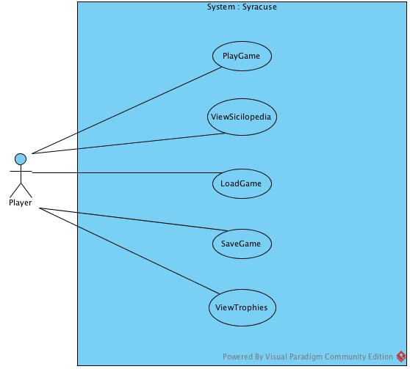

### 5.1.1. Play Game

**Participating Actors:** Player

**Entering Condition:** Player has already opened the game and clicks the play button.

**Exit Conditions:**

1- Player loses the game in one of the three ages OR

2- Player wins the game by completing one of the achievements in the third age OR

3- Player chooses to exit the game by clicking on the exit button

**Main flow of events:**

1- Player starts the game

2- Player chooses the difficulty

3- Player chooses two of the adjacent provinces for raw resources supply

4- Player completes all the missions in the required time and goes to step 5 OR player is not able to complete the missions in the given time and goes to step 11

5- Player progresses to the second age

6- Player chooses two more of the adjacent provinces for raw material supply

7- Player declares war with either Athens or Sparta

8- Player builds an army and successfully defends its territory from invasion and goes to step 9 OR player loses his/her territory and goes to step 11

9- Player progresses to the third age

10- Player wins the game by completing one or more of the following achievements

A- Controlling the three cities of Sicily

B- Being in alliance with Carthage or Rome when one of them, conquers the other’s capital.

C- Constructing a wonder building in the city

11- Player has lost the game and starts over again OR exits the game

### 5.1.2. View Sicilopedia

**Participating Actors:** Player

**Entering Condition:** Player clicks the sicilopedia button from either the main menu or during the game

**Exit Condition:** Player clicks the exit button and goes back to either the main menu or the game.

**Main flow of events:**

1- Player clicks on the sicilopedia button

2- The sicilopedia screen pops up and the player reads the information

3- The player clicks the exit button and goes back to the screen he/she came from.

### 5.1.3. Load Game

**Participating Actors:** Player

**Entering Condition:** Player clicks the load button from the main screen.

**Exit Condition:** Player clicks the exit button and goes back to either the main menu or the game or loads a already saved game.

**Main flow of events:**

1- Player clicks on the load button

2- The load screen pops up and the player chooses a saved game and goes

to step 3 OR there is no saved game available and the player goes to step

4

3- The correct files are fetched from the HDD and the game state is restored to represent that saved game.

4- An error message is displayed saying that there is no saved game available and the player clicks the exit button and goes back to the screen he/she came from.

### 5.1.4. Save Game

**Participating Actors:** Player

**Entering Condition:** Player clicks the save button in the game screen.

**Exit Condition:** Player clicks the exit button and goes back to the game.

**Main flow of events:**

1- Player clicks on the save button

2- The save screen pops up and the player saves the game

3- The player clicks the exit button and goes back to game screen.

### 5.1.5. View Trophies

**Participating Actors:** Player

**Entering Condition:** Player clicks the trophies button while in the game screen or from the main menu.

**Exit Condition:** Player clicks the exit button and goes back to the game or the main menu.

**Main flow of events:**

1- Player clicks on the trophies button

2- The trophies screen pops up and the player sees his/her past achievements

3- The player clicks the exit button and goes back to game screen or the main menu

1. http://www.worldoftropico.com/us/
2. http://www.worldoftropico.com/us/
3. http://www.simcity.com/
4. http://www.pogo.com/games/risk#game
5. http://www.moddb.com/mods/war-of-empires1
6. http://store.steampowered.com/app/245620/?l=turkish
7. http://www.travian.com.tr/